|  |  |
| --- | --- |
| http://www.gbu.co.za/trees/pierneeff.jpg | Jacob Hendrik Pierneef - who loved our trees Prominent South African artist whose modernist and geometric style revolutionized South African art in the early 20th century.Pierneef is often named as South Africa's greatest painter and his work is widely praised for its combination of raw genius and dedication to technique. |

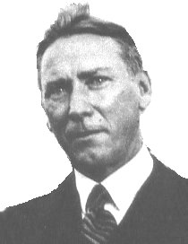Hendrik Pierneef (1886 - 1957) was born in Pretoria on 13 August 1886, the year Johannesburg was founded. His father, Gerrit Pierneef a Dutch builder, built the first house in Market Street; his mother, Neeske, was a descendent of Trekkers. Due to family financial constraints, Hendrik Pierneef received little formal training during his younger years, but did attend the Staats Model School in Pretoria, where he excelled at drawing.  
During the Anglo-Boer war, the family left for the Netherlands, where he came into contact with the paintings of the old masters. During 1900, Pierneef studied drawing under an architect at Hilversum. He worked part time in a paint factory, attending night classes in drawing. In 1901 he studied at Rotterdamse Kusakademie.

On returning to South Africa, aged 18, he was encouraged by established artists in South Africa : Frans Oerder, Hugo Naude and sculptor Anton van Wouw, who was his godfather. Pierneef started work in a tobacco shop, but he continued to study art. His first exhibition in 1902 was with Anton van Wouw and Hugo Naude. During the years 1905-08, he studied under Frans Oerder. In 1908 he studied etching and wood engraving under G.S. Smithard. His first oil painting was sold in 1910. In 1910, Pierneef married Agatha Delen, a woman 12 years his senior.

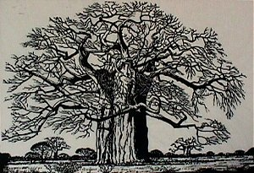  
He was appointed in 1912, to a position at the State Library, Pretoria. Pierneef held his first solo exhibition in 1913 and participated in many group exhibitions. Pierneef exhibited as a member of The Individualists Group and in 1917, he was elected a member of The South African Society of Art.

He drew illustrations for "Die Brandwag" and executed many linocuts, like the Baobab on the right.

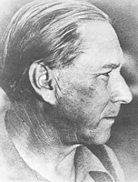He worked for 10 years in the State Library before he accepted a position as an art lecturer at the Heidelberg College of Education. He started teaching drawing at the Pretoria College of Education in 1919.  
Due to the recognition that he received, Pierneef realised that he was setting the trend for a unique South African style. Personally, this was a difficult time in his life - his wife Agatha suffered from a mental disorder and also started to lose her sight.  
S H Pellisier Art Gallery (visits by appointment only. 051 933 2250) in Ficksburg is named after Samuel Henri Pellissier, who commissioned J H Pierneef to paint the Bushman murals and frieze on the walls of the Ficksburg High School hall. Pierneef was 36 years old at the time. As well as the frieze, there are eight panels in all. Work commenced in February of 1922 and took two months to complete.  
During 1923, when the market for his paintings was improving, he made the decision to become a full-time artist and embarked on a painting expedition to Namibia, the first of many excursions into the countryside he loved. Pierneef lived in Namibia between 1923 - 1924. Despite his successes, he was experiencing some financial difficulties, and had to resort to other jobs in order to make ends meet. During one of these, an advertising project to sell the land around Hartebeespoort dam, he met his future second wife, a 35 year old Nederlands woman named Marian Frances Schoep (May). Pierneef divorced Agatha in 1923 and married May in 1924.  
  
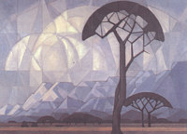Hendrik and May Pierneef visited Europe from 1925 to 1926, where Pierneef promoted his art and also studied the newest art movements. He held a solo exhibition in the Netherlands, where his [San (Bushmen) drawings](http://www.gbu.co.za/trees/pierneef_bushmen.html) drew great attention.  
In 1927 Pierneef’s daughter was born and he held a very successful exhibition of 86 of his works in Pretoria. However, during his solo exhibition the following year, he had some abstract modern works on display, which were very badly received, forcing him to revert to his old style.

STATION PANELS  
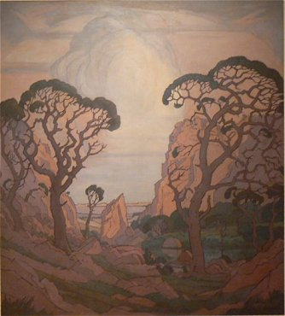The peak of Pierneef’s development as an artist is marked by the 32 panels he was commissioned to produce for the new Johannesburg Station which replaced the Zuid-Afrikaansche Republiek Park Station in 1929, completed by 1932.

The painting of the ‘Station Panels’ was a daunting task both in number and size. The 28 larger canvasses measured approximately 150 x 140 cm’s each, and depicted landscapes of different parts of Southern Africa. This project created enormous publicity for the artist, as the Railways were responsible for the promotion of tourism both nationally and internationally, and Johannesburg Railway Station became the main point of embarkation for visitors, whether tourists or businessmen, as the age of air transport had yet to arrive. The ‘Station Panels’ were installed by the end of 1932, and included four smaller panels of indigenous trees. The enormous number of preliminary studies done in preparation of this commission provided Pierneef with source material for a great number of paintings, watercolours and linocuts with different variations on these themes. The ‘Station Panels’ were exhibited in Graaf-Reinet during 2007. [click to see them!](http://www.gbu.co.za/trees/stationpanels.jpg)  
Pierneef's primary theme was landscapes and he worked mainly on wood, linoleum and casein, and in pencil, watercolours and oils. He devoted some attention to indigenous rock paintings but abandoned these studies.  
From 1933 to 1935 he was in London, fulfilling the commission of seven murals for South Africa House on Trafalgar Square.  
  
Pierneef's style presents a formal, ordered and monumental view of the South African landscape, rarely depicting humans or animals. He remains one of South Africa's leading landscape artists, whose distinctive style is widely recognized.

During 1939 Jacob Pierneef purchased a small farm east of Pretoria, where a house (in the form of a "kraal") was constructed from the stone on the farm and the grass used for thatching. There is a big studio for exibiting paintings and a garden. Pierneef's admiration for the rock artists was epitomised by the copy of a drawing of a resting eland he had his friend, the sculptor Coert Steynberg, carve in relief into the door of the gateway leading to the "kraal" of his home "Elangeni" a Zulu word meaning "in the sun". The property is in present-day Moepel Street, Lynnwood.

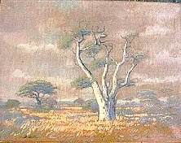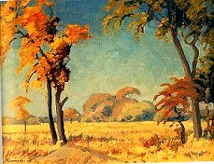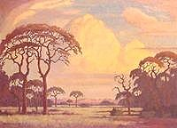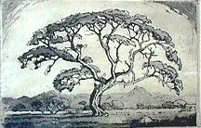

|  |  |  |
| --- | --- | --- |
| http://www.gbu.co.za/trees/pierneef_roots.jpg<> | *“Bury me under a camel thorn tree, with its straight manly character guarding me, and its roots deep in the soil of Africa”*. | http://www.gbu.co.za/trees/pierneef_photo.jpg |
| Jacob Hendrik Pierneef died on 4 October 1957. | | |

During the 1970s, Pierneef's daughter, Marita ("Miekie") Bailey, and her husband established the Bailey Collection, made up of a large number of South Africa's works and personal effects which had been in their possession, plus numerous items which they sought out and acquired from various other quarters. A portion of this Collection was purchased by the South African Department of National Education in 1975. The rest of the Collection, made up of some 350 items, was placed on public exhibition in a small gallery created for the purpose in Stellenbosch, where the Baileys lived. In 1980, the Department purchased the remainder of the Bailey Collection, with the aim of ultimately creating a Pierneef Museum. Meanwhile the Collection would be housed in the Pretoria Art Museum.

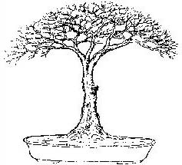

PIERNEEF STYLE BONSAI:  
Charles Ceronio, Pretoria Bonsai grower, gave a talk on "The Winds of Change to Indigenous Bonsai Styles for South Africa" at the first bonsai convention held in Cape Town in 1980. Charles introduced South African bonsai enthusiasts to six new African styles that he had created, which included the Pierneef or Umbrella-shaped style.

AWARDS:  
Pierneef received numerous honours and awards during his lifetime, including:  
1935 - The Medal for Visual Arts for his Johannesburg Station Panels as well as for his panels in South Africa House in London  
1951 – Honorary Doctorate, University of Natal  
1957 - Honorary Doctorate of Philosophy, University of Pretoria  
1957 - Honorary Membership of the South African Academy for Science and Art (‘’Suid-Afrikaanse Akademie vir Wetenskap en Kuns’’)  
  
PUBLIC COMMISSIONS:  
1924 - Ficksburg High School, Orange Free State, Bushmen Panels  
1929-32 - Johannesburg Railway Station panels  
1933-35 - Panels for South Africa House in London  
1937 - Mural for SS Pretoria Castle  
1940 - Two large pictures, Johannesburg Magistrates Courts  
1955 - Broadcast House, Johannesburg  
  
PUBLIC COLLECTIONS  
A.C White Gallery, Bloemfontein  
Ann Bryant Art Gallery, East London  
Durban Art Gallery  
Johannesburg Art Gallery  
Johannesburg Railway Station Museum  
King George VI Gallery, Port Elizabeth  
Pietersburg Collection  
Pretoria Art Museum  
Rembrandt Art Foundation  
Sandton Municipal Collection  
S.A National Gallery, Cape Town  
UNISA  
University of the Witwatersrand  
William Humpreys Galley, Kimberley  
  
Acknowledgements:  
http://wwar.com/masters/p/pierneef-jacob_hendrik.html  
http://www.lifewithart.com/artists/jacob-hendrik-pierneef.html  
http://www.everardread.co.za/Biographies/Pierneef%20JH.htm http://www.vgallery.co.za/2000article33/vzine.htm  
http://arty-fartying-around.blogspot.com/search/label/GRAAFF%20REINET   
http://www.caveng.ch/martin/index.asp?seite=42  
http://www.arcyart.com/sah-pierneef.htm